**NAME**: S SHELVASUJITH

**REG NO**: 192124191

|  |  |
| --- | --- |
| **Ex. No. 3** | **CONFIGURATION OF BUS TOPOLOGY** |
| **Date:3-10-2023** |

### AIM:

To Design and Configuration of Bus Topologies using Packet Tracer

### REQUIREMENTS:

1. End device - They are the devices through which we can pass message from one device to another and they are interconnected.
2. Switch/Hub - Interface Between two devices.
3. Cable - Used to connect two devices.

**BUS TOPOLOGY**

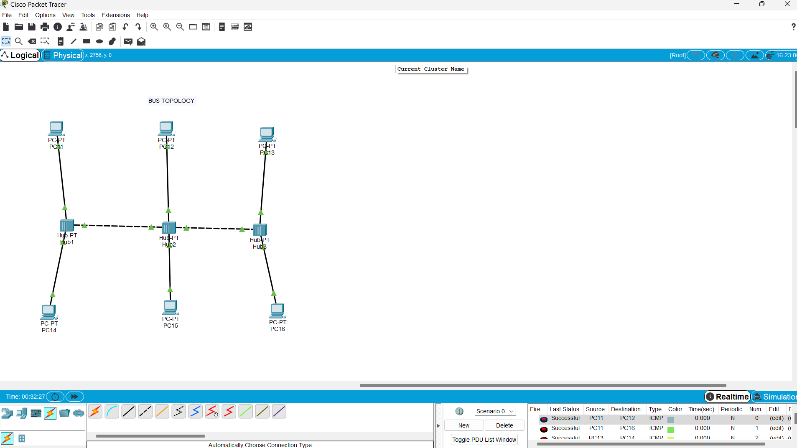

**PROCEDURE**

STEP 1: Click on end devices, select generic Pc’s drag and drop it on the

window. Click on SWITCH drag and drop it on the window.

STEP 2: Select the straight through cable and connect all end device to switch. Assign the IP address for all end devices. (Double click the end device Select →

desktop → IP configuration static)

STEP 3: Now set the IP address to Host A (192.168.1.1) in static mode. Similarly set IP address for Host B (192.168.1.2) and Host C (192.168.1.3)

STEP 5: To view the IP address, give ipconfig command in command prompt. Using ping command, we can establish communication between two host devices.

STEP 6: Now display the packet transmission in simulation mode.

**RESULT**

Configuration of bus topology is successful